**Exception Handling**

What are Exceptions ?

Ans: Exceptions Are RunTime Errors

Types of Errors:

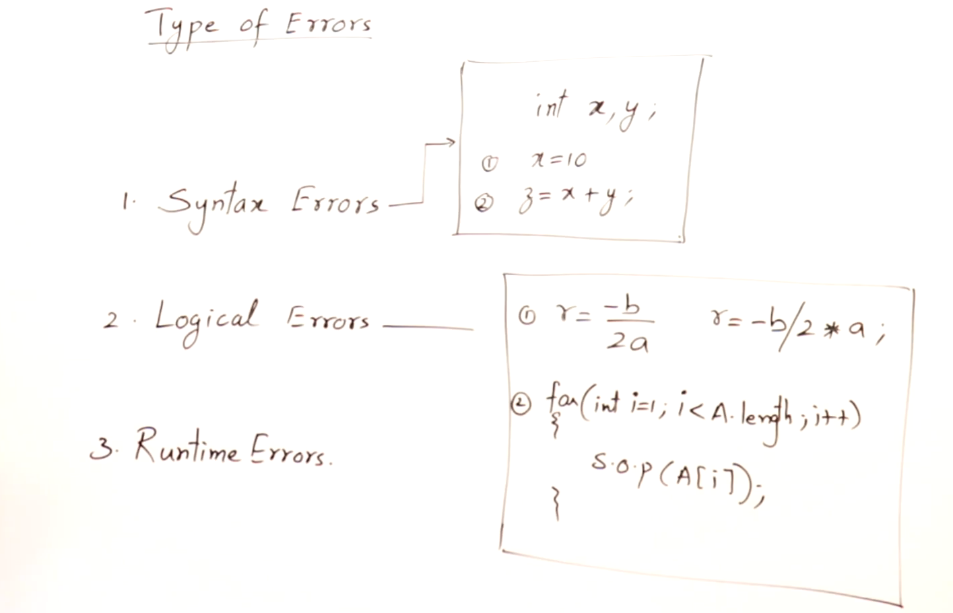

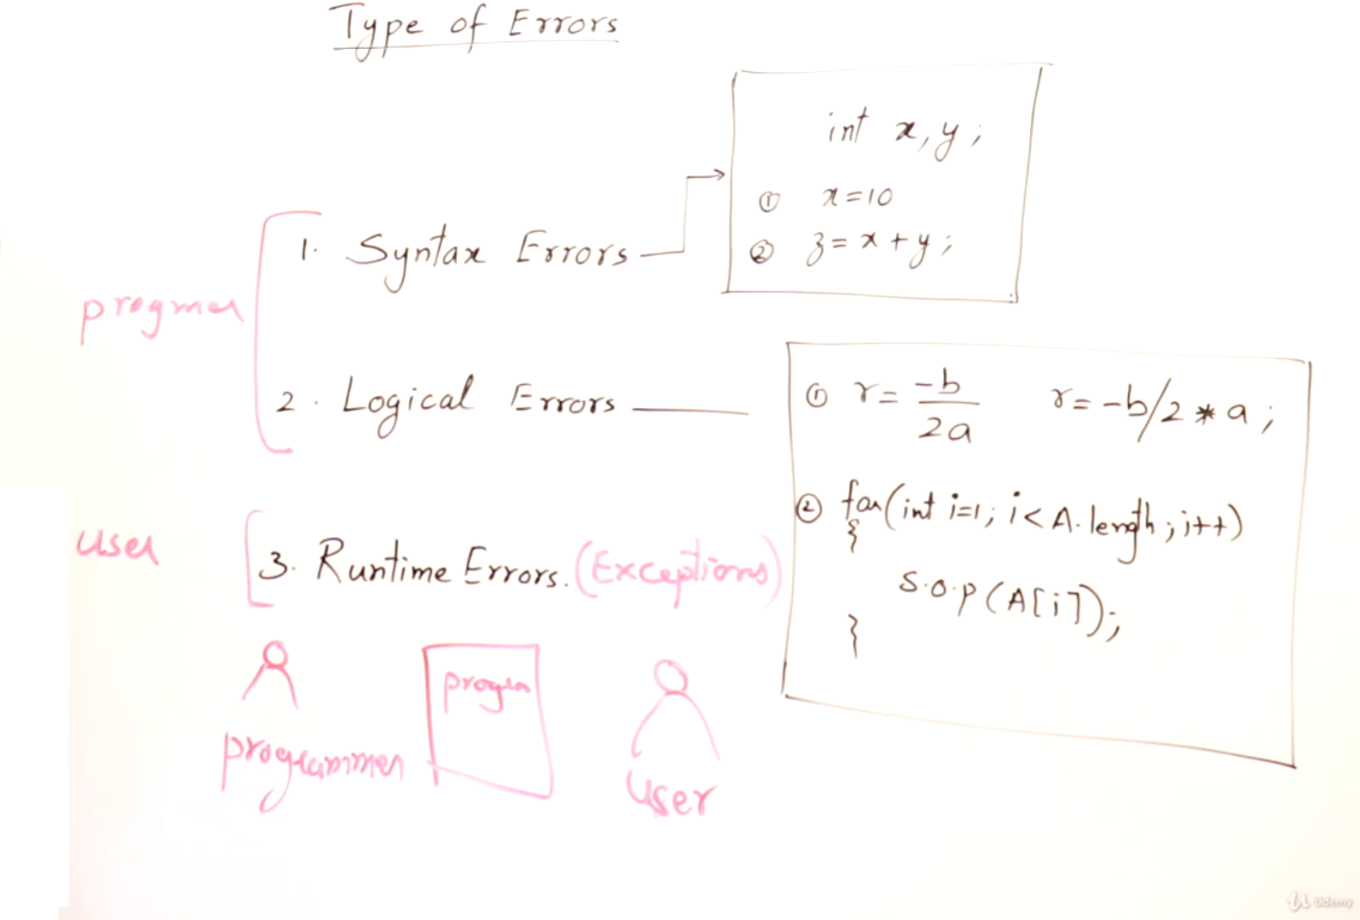

**Syntax Errror:** If a programmer is doing some mistakes,

that is syntactic mistake or a grammatical mistake or spelling mistakes, then that causes errors that are syntax Errors

*These type of errors can be removed by compiler.So when you compile a code which have errors compiler simply can’t convert it to byte code it simply gives you an errors says that line of code having this error

**Logical Error:** If a programmer is compiling and trying to run any test, the program not giving expected results

*These type of errors can removed by certain tools

Like: Tracing/Debugger

**Runtime errors:**

These type of errors are faced by User.

For one thing, remember, user cannot do anything in the program.

he can only use it.

So why the user gets these errors because User is misusing the program he is not using the program as it supposed to be used

But it’s Programmers responsibility that provide the reason why the user is getting that error

Like if user is providing invalid input or a file of the program is missing.

**And this is done by exception handling.**